S1 Referral Guide for Community services
Refer a patient to Healthy Hounslow

Guidance
On 1st April 2023, OneYou Hounslow ended and was replaced by Healthy Hounslow. Borough wide referrals for lifestyle services should follow the following guidance.
Healthy Hounslow is an alliance of providers who deliver the following services:
- Health and wellbeing coaching
- Smoking cessation
- Cook & Eat programme
- Community physical activity
- Exercise on referral
- Child/young person weight management
- Adult weight management
A single standardised S1 referral template is available for all services under Healthy Hounslow.
Referrals to Healthy Hounslow from Hounslow Community services should be submitted Via NHS Mail SystmOne for all patients who consent to data sharing (morelife.hounslowreferrals@nhs.net)
Service outcomes will be returned back to Primary Care in two ways:
- A pre-populated template will be sent via Secure NHS Mail direct to the registered practice.
- Outcomes data will also be coded directly into the patient record.
Referrals for eligible clients can be made by any qualified practitioner.

Instruction
- Retrieve the patient you wish to refer to Healthy Hounslow.

- Navigate to Communications and Letters.

- Right click on Communications & Letters and select ‘new letter’.

- Within the Sender & Recipient Type, select ‘this organisation & the patient’.

- Select Choose Template.

- Scroll down to the SPA folder and click on the little black arrow to expand the folder.
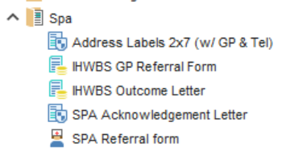

- Left click on ‘IHWBS GP Referral Form’ and click ‘OK’.

- Fill in the parts highlighted in light blue on the form and select ‘Save as Final Version’ to complete and save the completed form to the patients record.

- Find the completed form within Communications and Letters, right click on the saved form and select ‘Send via NHS Mail’.

- Select ‘Existing Contact’.

- Select “Healthy Hounslow (Formally known as OneYou Hounslow) within ‘Organisation Contacts’ and left click on ‘Select’

Please Note: If this entry does not appear in your address book, please log a query with our helpdesk: SystmAdmins Helpdesk Request Form (jotform.com)

- Select Yes

- Save the patients record appropriately

