2024

Electronic Referrals (SystmOne to SystmOne)

Healthy Hounslow

Primary Care Systems Team

Contents

This user guide is aimed at providing staff with an understanding of how to electronically refer a patient to the Healthy Hounslow Service – Morelife.

It is the legal responsibility to protect patient confidentiality. The responsibility for safeguarding and using confidential information appropriately rests with each organisation.

Introduction 1

1. Sharing List 1

2. Using the Referral Wizard 2

Disclaimer: 5

### Introduction

From 24th June 2024, the Morelife Service has its own SystmOne Community Unit. Electronic referrals can be made via the SystmOne referral wizard directly to the Morelife SystmOne Unit.

1. Sharing List

Please ensure that you have added the new organisation to your Sharing List.

From the Main Menu, select **Setup**> **Users and Policy**> **Share in Rules**> **Add Organisation**

Organisation: MORELIFE Hounslow SPA

Unit ID: 8HV71

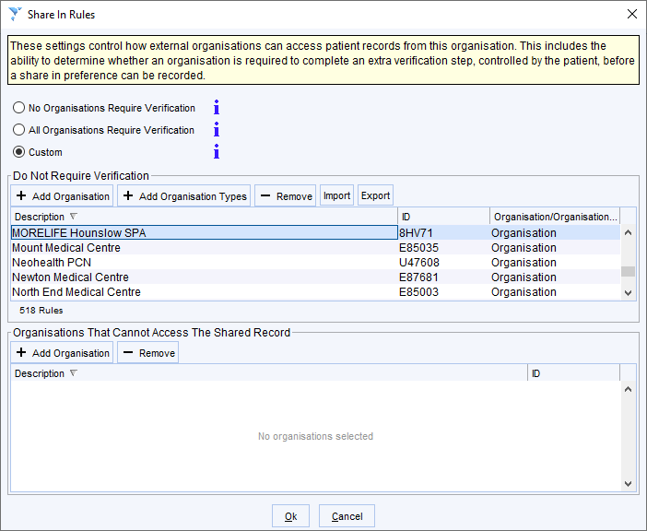

1. Using the Referral Wizard

* With the patient record open, navigate to the **Referrals** node on the **clinical tree**
* Right click and select **Referral Wizard**

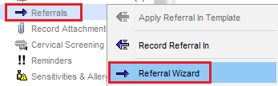

* From the **CCG Contacts** tab, select the **Referral Recipient** - **Healthy Hounslow Referral Form (Electronic) –** HN. This is located in the **Health Promotion/Hounslow** folder

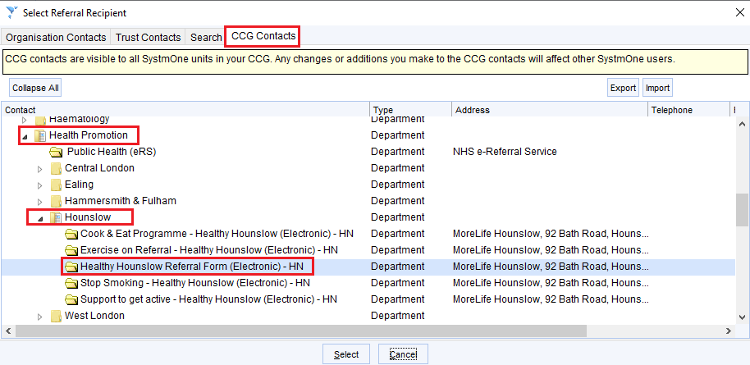

* The **New Electronic Referral** window will open

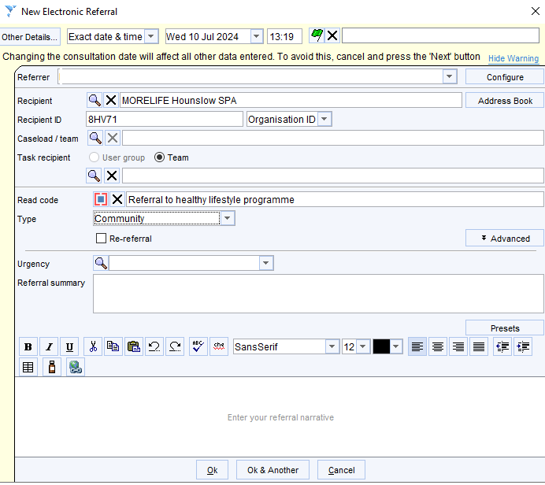

* PLEASE DO NOT ASSIGN A CASELOAD
* Select **Type** – Community
* Select the **Urgency**
* Type in the **Referral Summary**
* Type in the reason/s for the referral in the **Enter your referral narrative** field
* Click **Ok**
* The sharing record **Question** will pop up

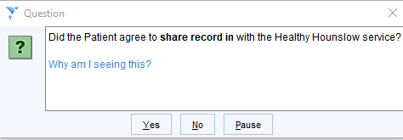

### If the patient has consented to share

* Click **Yes**
* The **Create Referral Letter Question** will pop up

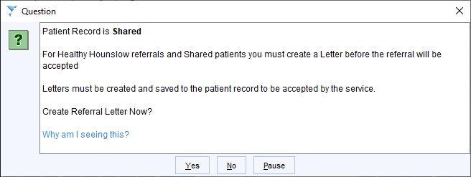

* Click **Yes**
* The New Letter window will open. It will be populated with Sender/Recipient details

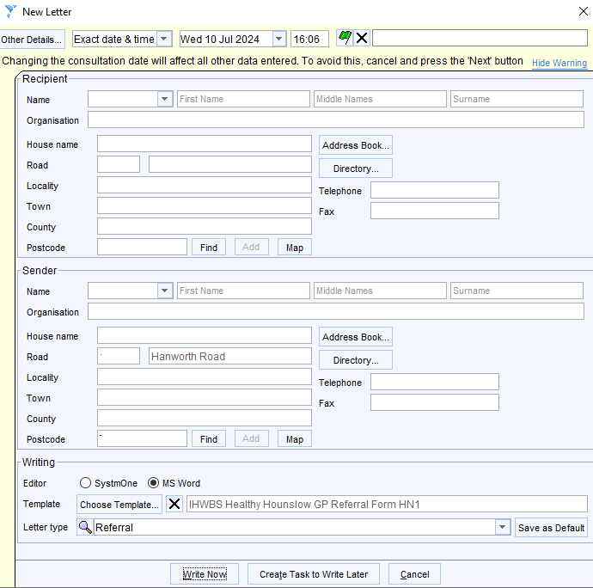

* Click **Write Now**
* The **Referral Form** will open in **SystmOne Mail Merge**
* Once you have completed the form as required, **Save Final Version**

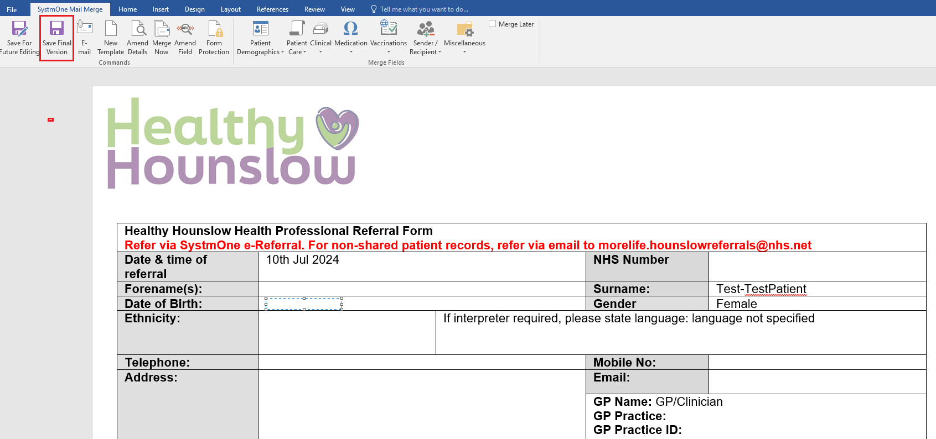

* You will see a Task Information message, click **OK**

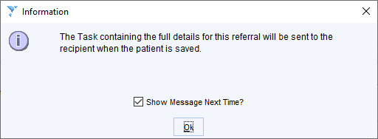

### If the patient has NOT consented to share

* Click **Yes** when you see this Question - You will still create the electronic referral, the patient record content will not be visible in the Morelife Unit

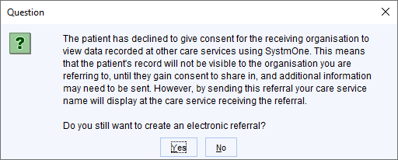

* The sharing record **Question** will pop up



* Click **No**
* A further **Question** will pop up, click **Yes** and proceed to complete the referral

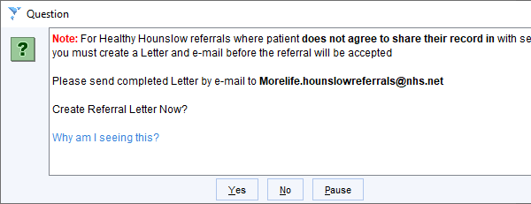

Please email referrals for patients who have declined consent to share, by NHS secure email to [morelife.hounslowreferrals@nhs.net](mailto:morelife.hounslowreferrals@nhs.net)

Disclaimer:

*To the best of our knowledge and using the available information, this guidance is correct at the time of publishing.*

Please do not hesitate to contact us if you have any queries via the IT Service Desk:

Phone: 0203 350 4050 or Email: [nhsnwl.servicedesk@nhs.net](mailto:nhsnwl.servicedesk@nhs.net)