Electronic Referral (SystmOne to SystmOne) for Healthy Hounslow

- Navigate to the Referrals node on the patient’s clinical tree and launch the Referral Wizard. Select Healthy Hounslow Referral Form – HN and click select
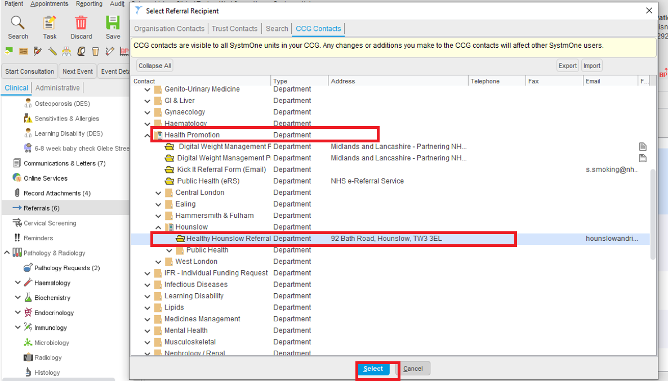

- The New Electronic Referral Screen below opens up;
- Select a Caseload
- Select Reason for Referral (usually Other)
- Select Urgency
- Type in Referral Summary
- Type in texts or reasons for referral in the white box
- Click ok
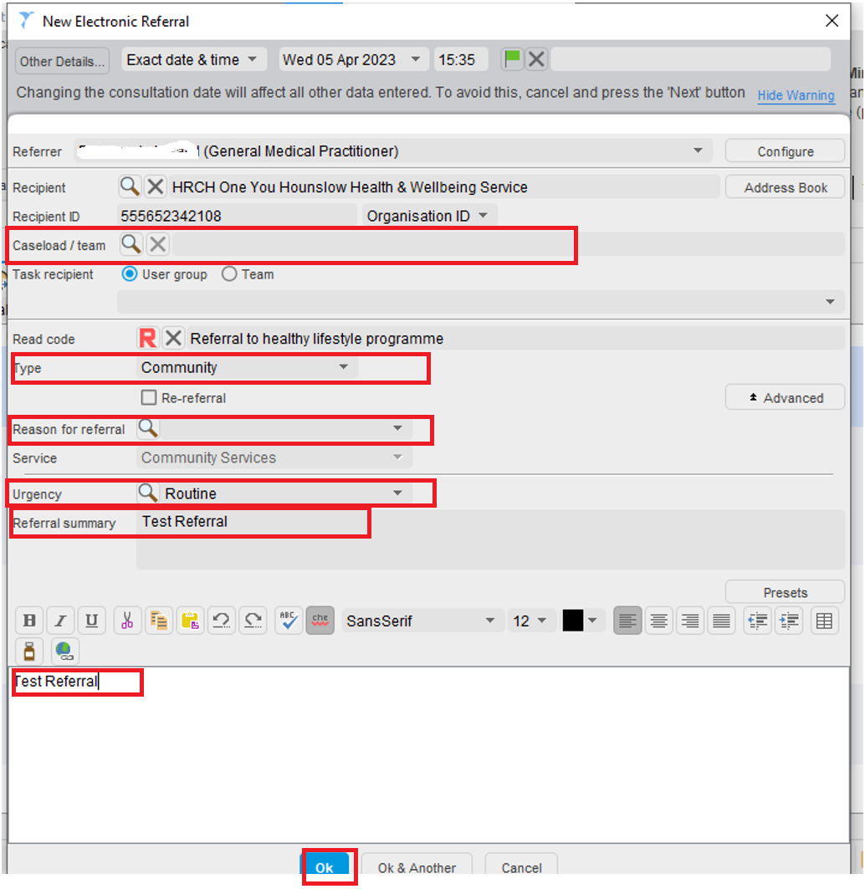

- The Sharing Record question box opens up;
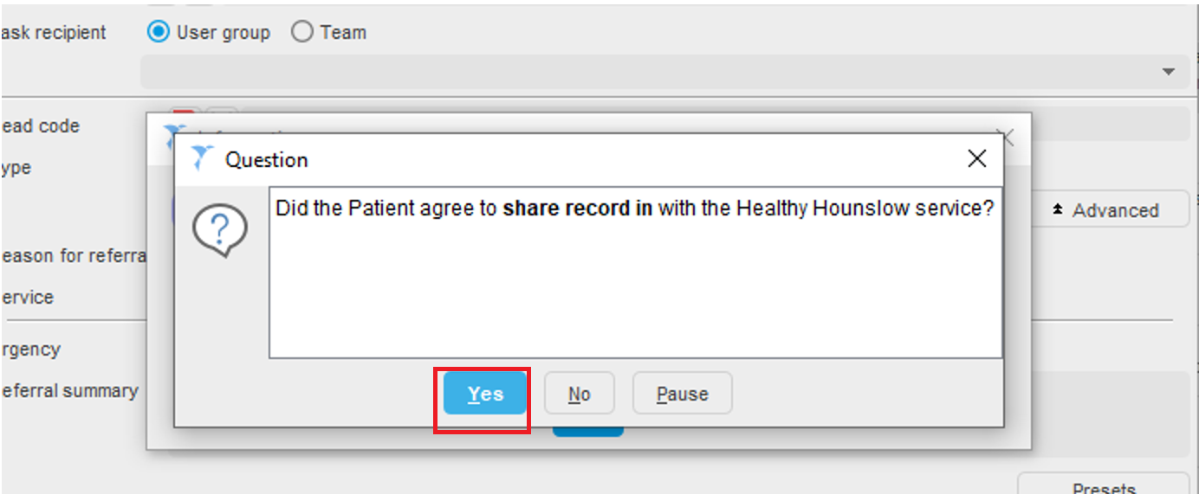

- If the answer to record sharing question is YES - then the below screen opens up. Click Yes to create Referral Letter
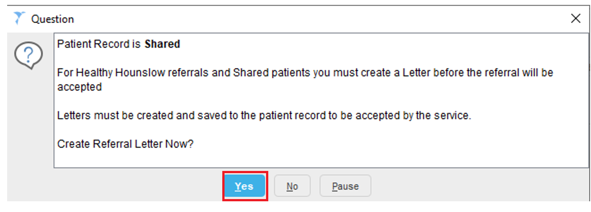

.

- A New letter screen opens up; select write now
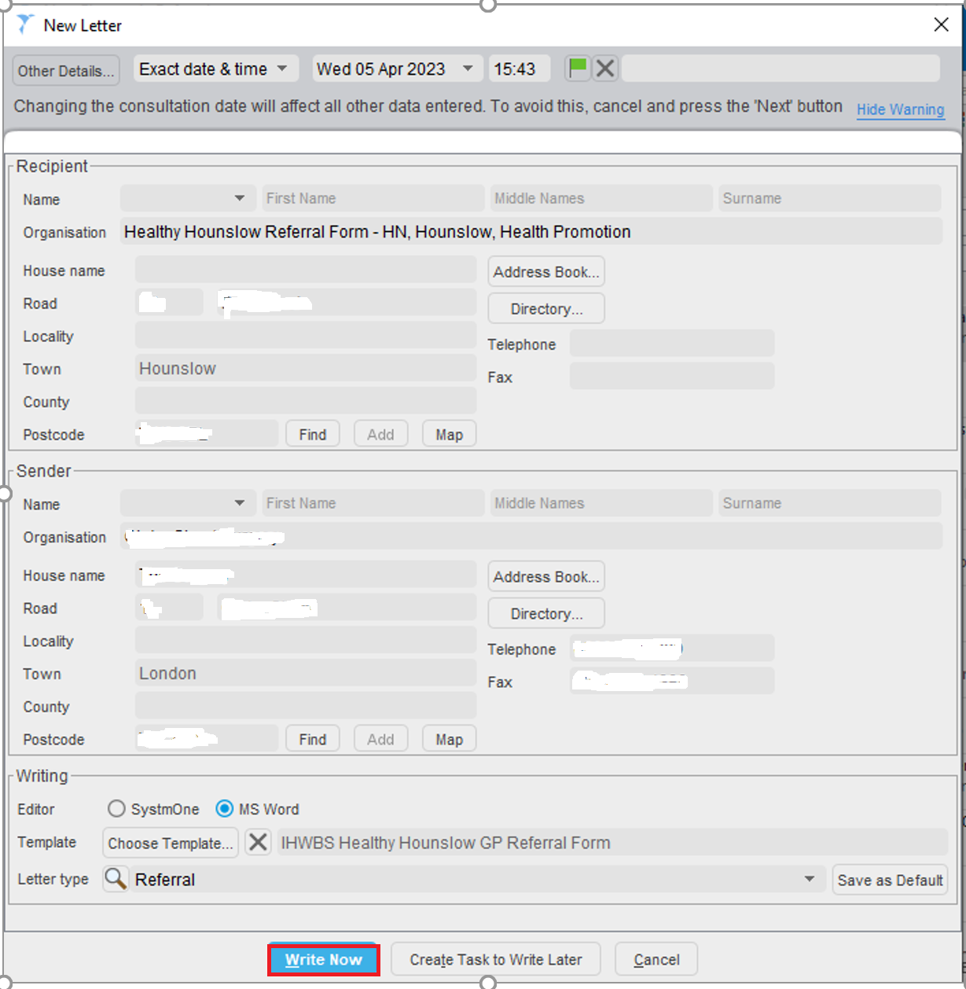

- The referral form opens up. Complete the referral form and save in the patients record.
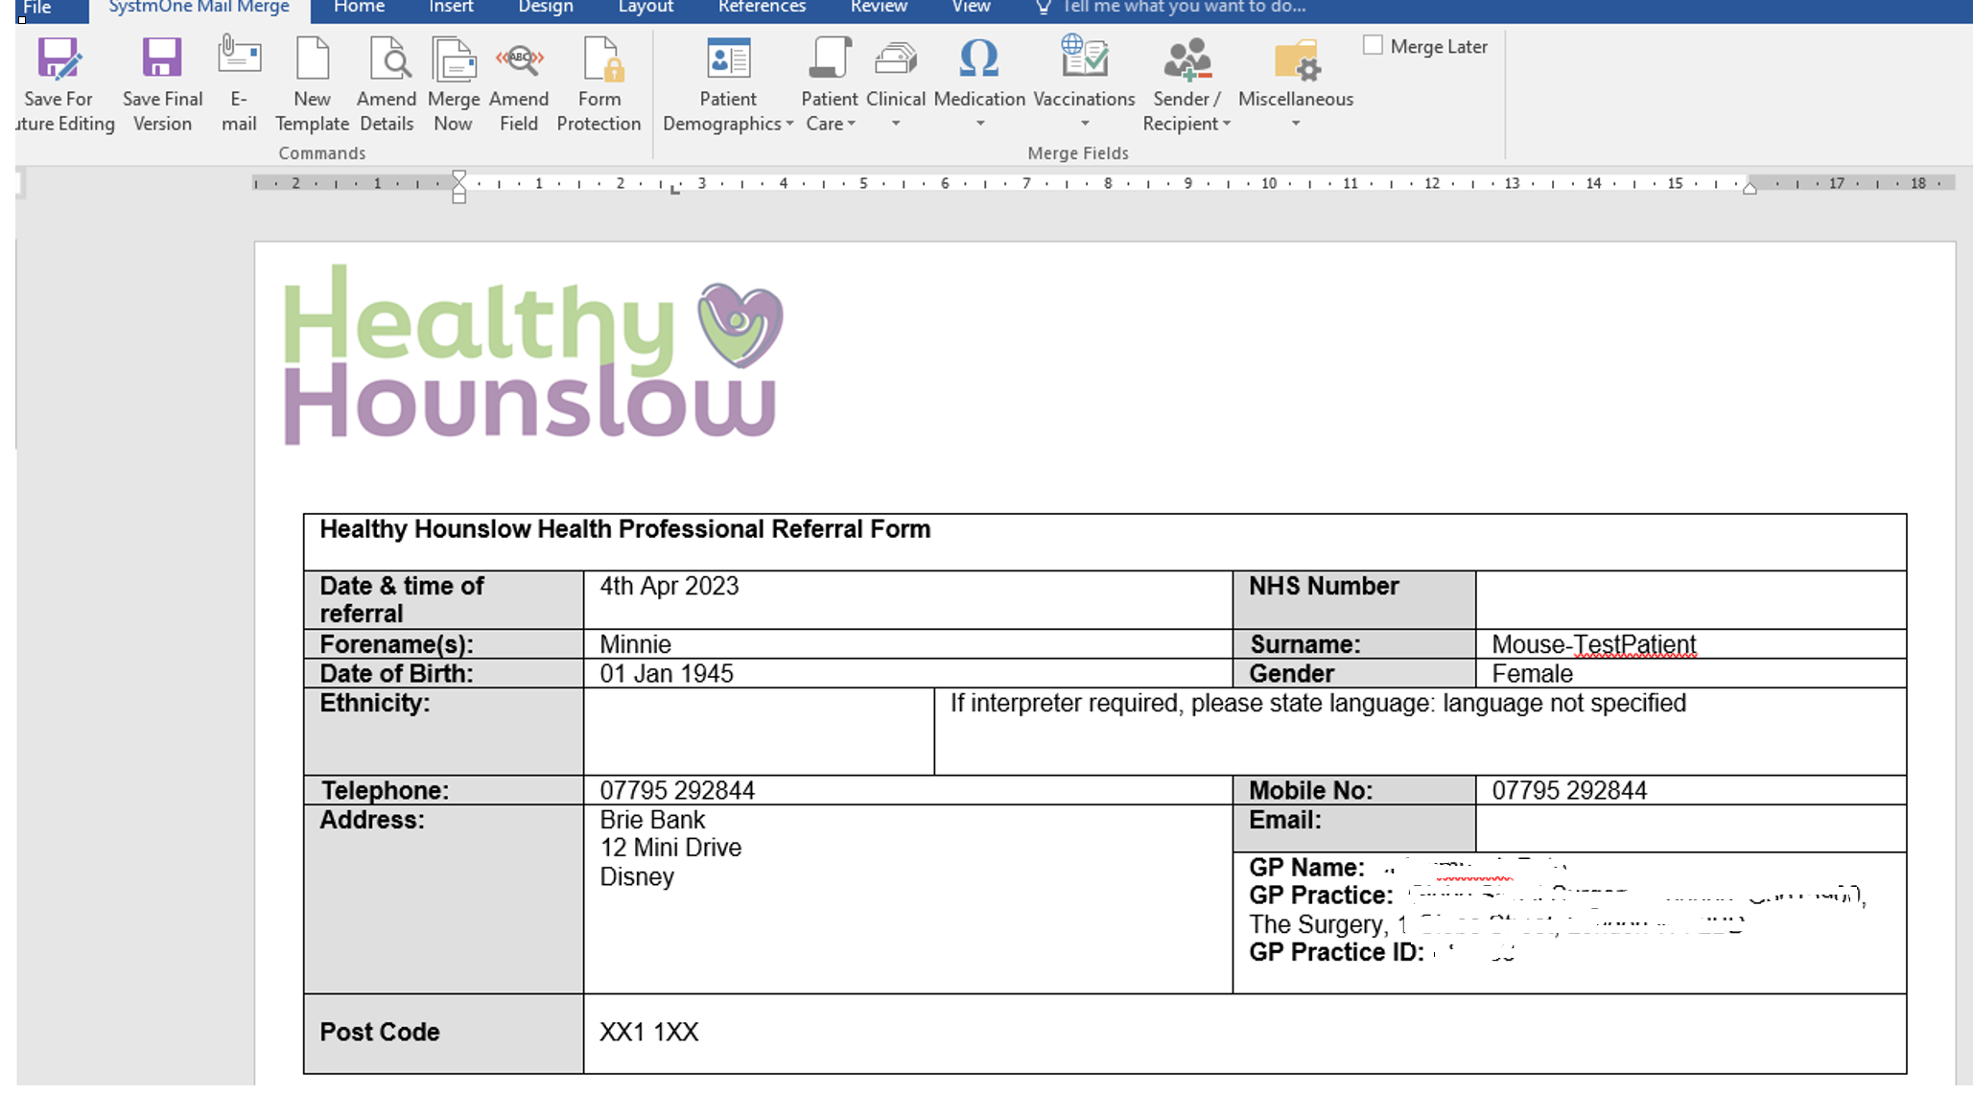

- If the answer to record sharing question is NO – then the below screen opens up. Click No.
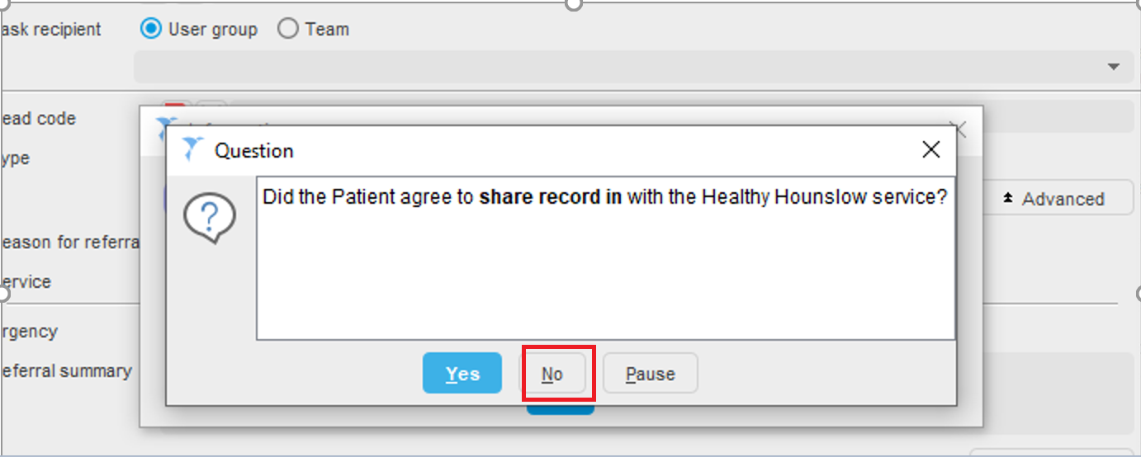

Then the below screen opens up
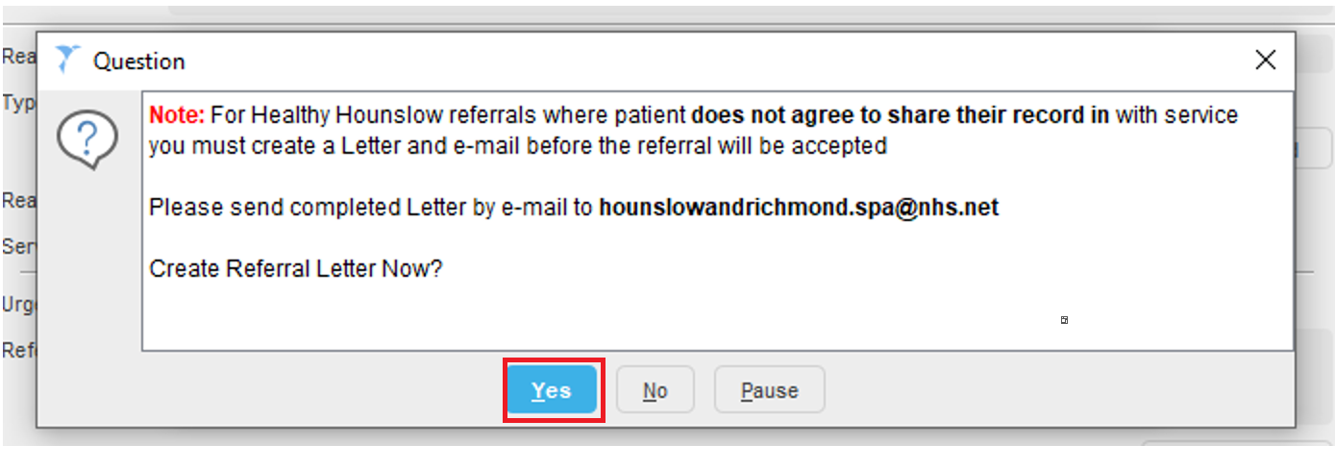

Select Yes, the referral form opens up , complete the referral form and then send completed form by email to Hounslowandrichmond.spa@nhs.net

