Quick Reference Guide
Refer a patient to Healthy Hounslow (Formally known as OneYou Hounslow)

Guidance
From 1st April onwards there will be changes to borough wide referrals for lifestyle services. OneYou Hounslow will cease and be replaced by Healthy Hounslow.
Under the new brand, an alliance of providers will deliver the following services:
- Health and wellbeing coaching
- Smoking cessation
- Cook & Eat programme
- Community physical activity
- Exercise on referral
- Child/young person weight management
- Adult weight management
A single standardised template for all services is available to Primary Care / HRCH for a referral into Healthy Hounslow.
Referrals to Healthy Hounslow from HRCH should be made by NHS Mail for all patients who consent to data sharing (hounslowandrichmond.spa@nhs.net)
Service outcomes will be returned back to Primary Care in two ways:
- A pre-populated template will be sent via Secure NHS Mail direct to the registered practice.
- Outcomes data will also be coded directly into the patient record.
Referrals for eligible clients can be made by any qualified practitioner.

Instruction
- Retrieve the patient you wish to refer to Healthy Hounslow.

- Navigate to Communications and Letters.

- Right click on Communications & Letters and select ‘new letter’.

- Within the Sender & Recipient Type, select ‘this organisation & the patient’.

- Select Choose Template.

- Scroll down to the SPA folder and click on the little black arrow to expand the folder.
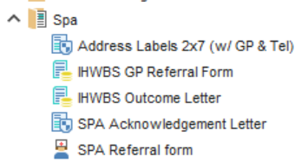

- Left click on ‘IHWBS GP Referral Form’ and click ‘OK’.

- Fill in the parts highlighted in light blue on the form and select ‘Save as Final Version’ to complete and save the completed form to the patients record.

- Find the completed form within Communications and Letters, right click on the saved form and select ‘Send via NHS Mail’.

- Select ‘Existing Contact’.

- Select SPA within ‘Organisation Contacts’ and left click on ‘Select’

- Select Yes

- Save the patients record appropriately

